Gas Exchange Name:________________
This happens in the ______________ inside the lungs.
_____________ (O₂) in the alveolus is exchanged for ____________ ____________ (CO₂) in the blood.
Air which has been ______________ has a higher concentration of Oxygen and a _____________ concentration of Carbon Dioxide.
Blood which has travelled around the body has a ____________ concentration of Carbon Dioxide and a _____________ concentration of Oxygen.
These gasses are exchanged in the alveolus via ___________.
So the blood leaving the lungs is now higher in Oxygen and lower in __________ ____________. The air which is exhaled from the lungs is higher in Carbon dioxide and lower in __________.

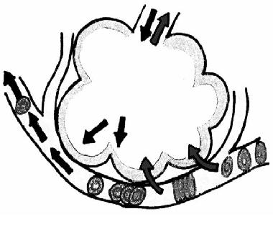
Label the arrows on the diagram below to show what happens during gas exchange.
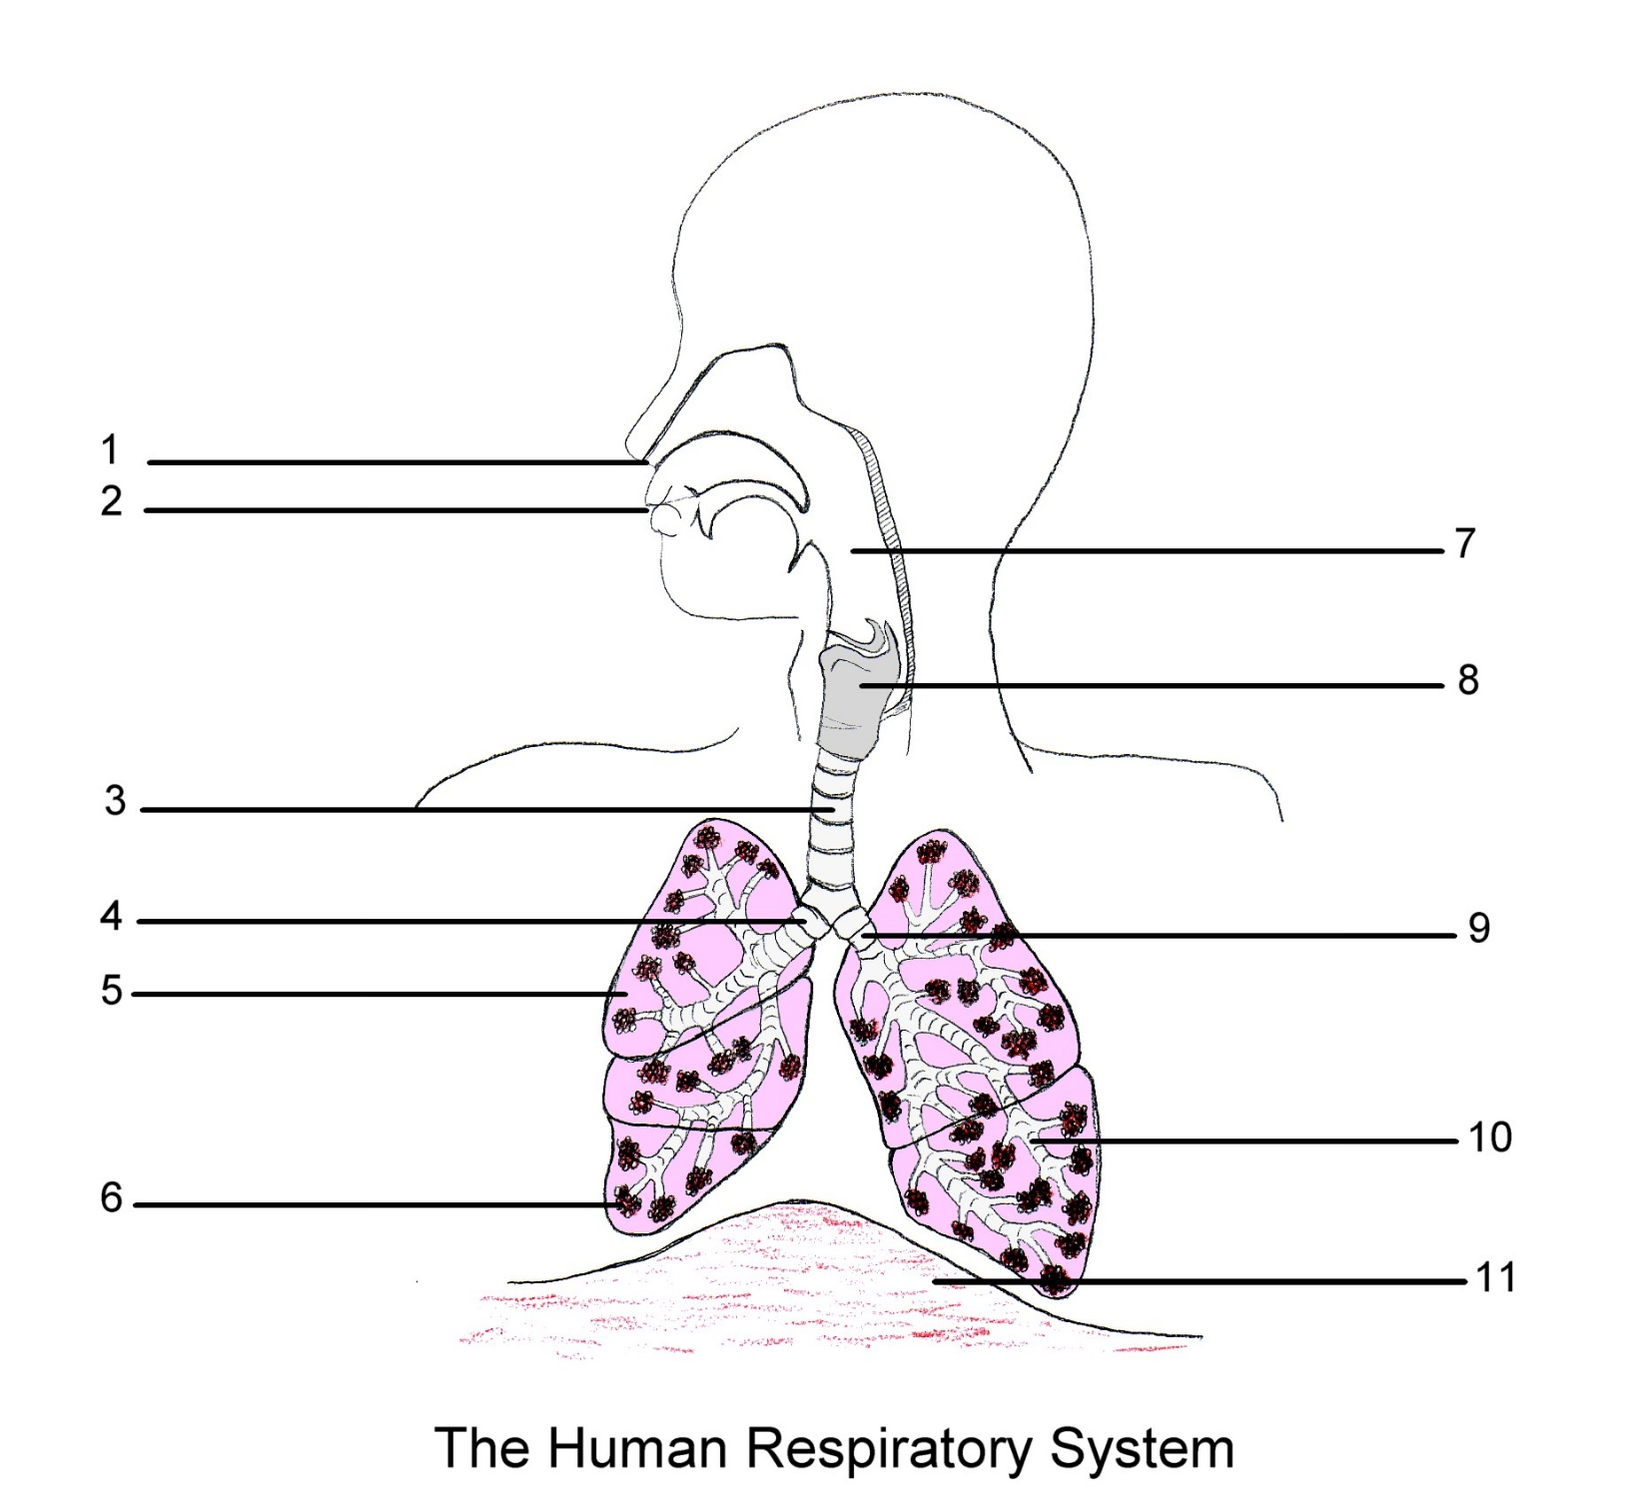
Label the features you recognise on the following diagram. Draw in some alveoli


